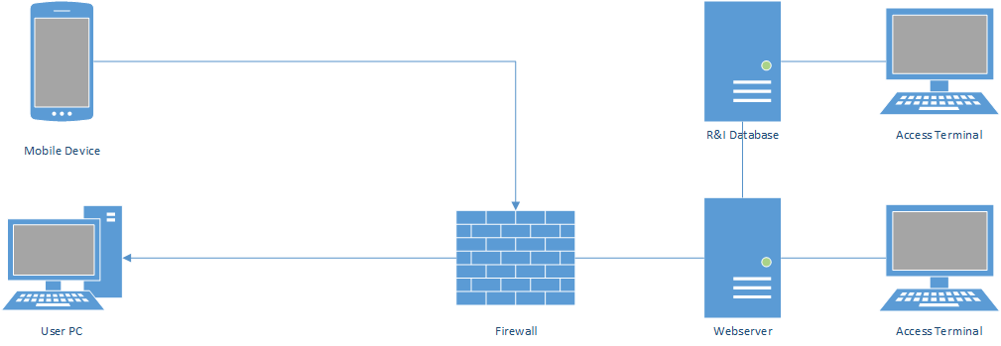

Mobile and desktop users will be able to access the website protected by the university firewall. The web server hosting the site will be connected to the Research and Innovation database which contains user profiles and data to be displayed on the site. Access terminals for both the webserver and the database will allow for administrative access whenever changes to the site or database are required.

Access Terminals and Web Server will run Windows Server 2019 while the database runs either Oracle or Windows Azure depending on if a cloud solution is needed